Lighting circuits

Connect lights using the loop at the light method

Step 1
Use the following area to sketch a circuit diagram of the following circuits:
- one way switching using the loop at the light method
- two way switching using the loop at the light method.

Step 2
Show your trainer your circuit diagrams and only move to the next step on their approval.

Step 3

Access the following equipment:
- single pole, double throw switch
- double pole, double throw switch
- continuity tester
- wiring
- batten holder/light fittings
- appropriate hand tools
- suitable work environment.

Step 4
Following the circuit diagram you have drawn for one way switching using the loop at the light method, run necessary wires to the appropriate positions.
 | 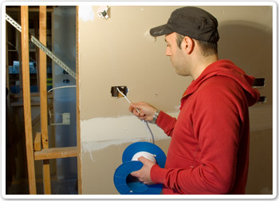
Following the circuit diagram | Running the wiring

Terminate the wiring at the batten.
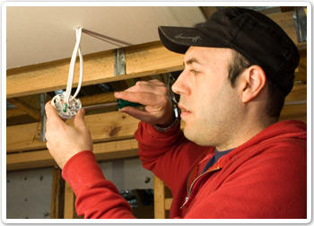 | 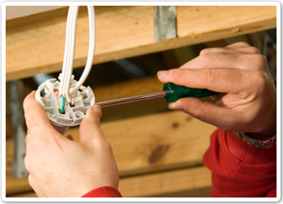
Termination at batten | Close up of wiring

Terminate the wiring at the switch.
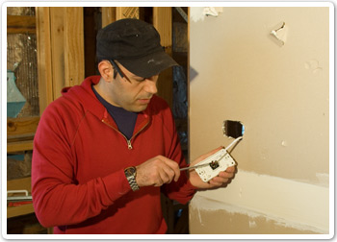 | 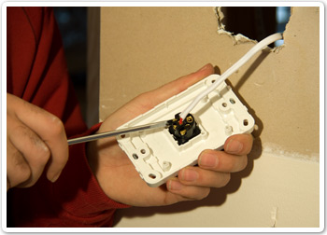
Termination at switch | Close up of wiring

When the connections are completed, test the circuit for correct operation.
Ask your trainer to check your work.

Step 5
Follow a similar process to complete an installation of two way switching of a light.
Test the circuit for correct operation at completion.
Ask your trainer to check your work.

