Electrical drawings
On the following page, redraw the circuit diagram below of a lighting circuit as a wiring diagram.

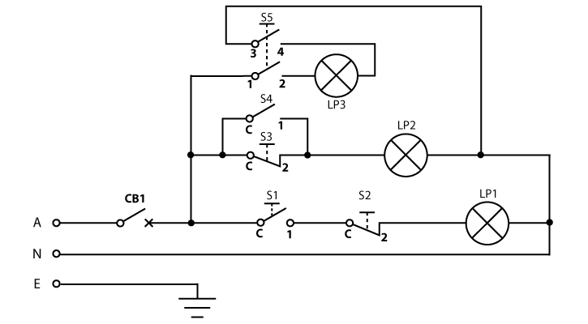

Wiring diagram

