Insulation testing
The following practical activity involves testing the insulation condition of a 240 volt installation. Completing the activity requires testing the insulation between all live conductors (including the neutral) and the earth.
See your trainer for approval before commencing the activity.
The activity can be substituted with an alternative insulation testing activity, See your trainer for more advice.

Step 1
Access the following equipment:
- bridging leads
- screwdriver
- insulation resistance (IR) tester
- 240 volt installation.
Note: See your trainer for advice on what electrical installation to use in performing this test.

Step 2
Prior to the test ensure that:
- the main switch is off (if using a live system)
- protective devices are active
- circuit switches are on
- fixed appliances are connected and turned on.
Note: See your trainer for specific instructions relevant to the system being tested.

Step 3
Place the system in the appropriate condition to allow the testing of insulation between live conductors (including neutral) and earth.
This may include the following:
- bridging the active and neutral
- bridging the meter connections
- disconnecting the MEN.

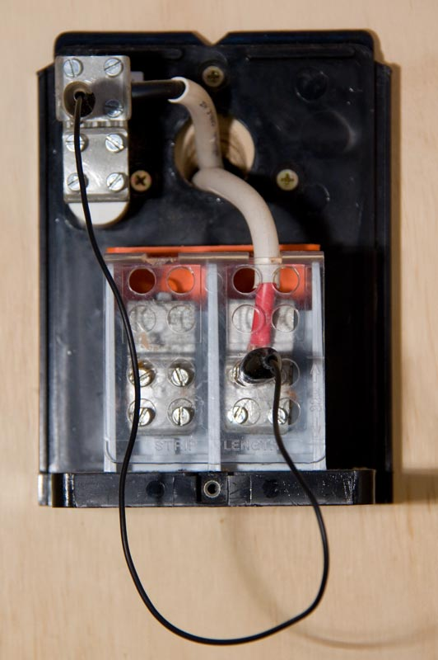 | 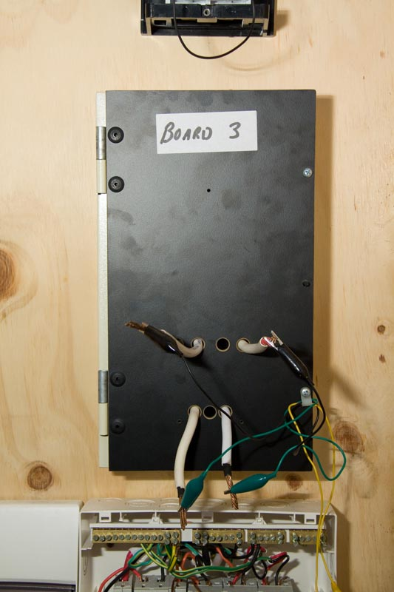
Active and neutral bridged | Meter bridged

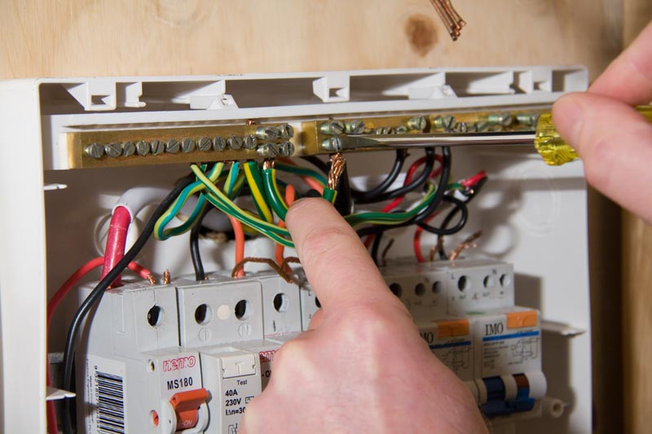
Disconnecting the MEN

Step 4
Correctly set the meter, connect to relevant positions in switchboard and test the insulation.

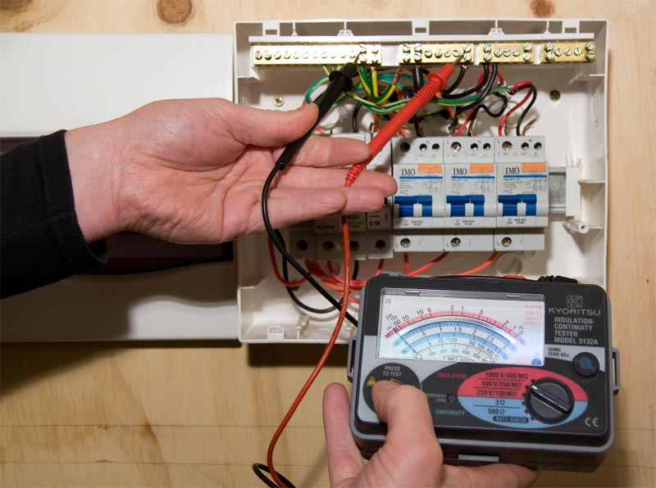
Testing the insulation

Step 5
Complete the following table.
Expected resistance reading | Actual resistance reading | Condition of the insulation

Step 6
Present your completed task sheet to your trainer for feedback.
Note: This completed task sheet can be saved as evidence of work completed.

