Using meters
The following practical activity involves using a clamp type ammeter and an LED voltage finder.
See your trainer for approval before commencing the activity.
The components or equipment suggested for use in this activity can be substituted with alternatives, see your trainer for more advice.

Step 1
Access the following equipment:
- clamp ammeter
- LED voltage finder
- 3 phase motor
- 240 volt installation
- 240 volt variable power supply.

Step 2
Conduct measurement using the clamp ammeter.
- Connect the 3 phase motor to the power supply.
- Turn on the power supply and run the motor.
- Set the clamp ammeter to measure current, and then place its jaws around one of the phase leads.
- Read the current flow reading and record it in the following table.
- Complete the same process with the other two phase leads.

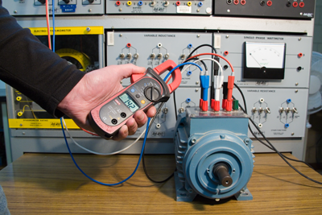 | 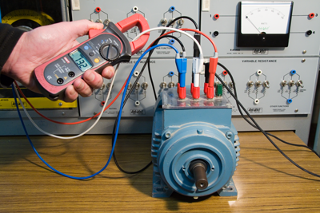
Measuring the current flow through individual motor phases

Current flow – Phase 1 | Current flow – Phase 2 | Current flow – Phase 3

Note: See your trainer for specific instructions relevant to the system being tested.
Question:
When a motor is operating correctly, the current flow through each of the three (3) phases will be a similar value. In what condition is the motor you have tested?

Step 3
Using the LED voltage finder, demonstrate to your trainer the ability to check voltage present in one or more situations.
This may include:
- output positions of a variable power supply
- various positions on a 240 volt installation.
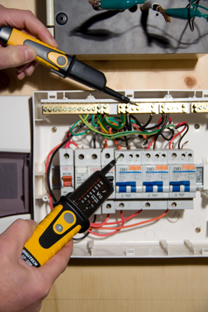 | 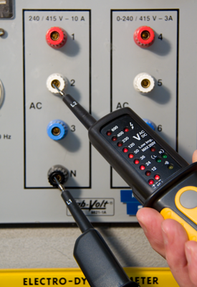
Using the LED voltage finder

Step 4
Present your completed task sheet to your trainer for feedback.
Note: This completed task sheet can be saved as evidence of work completed.

Step 5
Clean up and pack away all equipment and components used.

