Parallel measurement

Step 1
Access the following equipment:
- 12 volt power source
- 1 x 12Ω, 2 x 4Ω resistors
- connecting wires
- multimeter (or individual ammeter, voltmeter and ohmmeter).
Or
A circuit board for training purposes containing the above components, a suitable power source and meters.

Step 2
Connect up the circuit shown below.
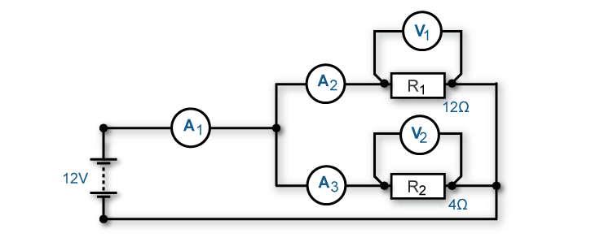

Note: If you are having any difficulty or are unsure how to connect this circuit, see your trainer for assistance and advice.

Step 3
Set the power source to 12V and turn on. Measure the voltage drop at V1 and V2 and the current flow at A1, A2 and A3. Turn off the power source and write your measured values in the following table.

 | Measured value | Predicted value | Difference between measured and predicted values
Voltage at V1

Voltage at V2

Current through A1

Current through A2

Current through A3

Step 4
Using the appropriate formula, calculate the predicted values you have measured. Place these values in the table above.
Calculate the difference between measured and predicted values and place in table.
Note: In the following area, show the formula you have used and your calculations.

Briefly explain possible reasons for a difference between measured and predicted values.

Step 5
Change your circuit to reflect the resistance values shown below.
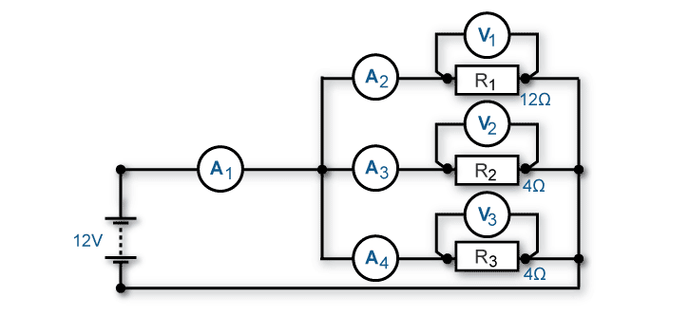

Step 6
Set the power source to 12V and turn on. Measure the voltage drop at V1, V2 and V3 and the current flow at A1, A2, A3 and A4. Turn off the power source and write your measured values in the following table.
 | Measured value | Predicted value | Difference between measured and predicted values
Voltage at V1

Voltage at V2

Voltage at V3

Current through A1

Current through A2

Current through A3

Current through A4

Step 7
Using the appropriate formula, calculate the predicted values you have measured. Place these values in the table above.
Calculate the difference between measured and predicted values and place in table.
Note: In the following area, show the formula you have used and your calculations.

Briefly explain possible reasons for a difference between measured and predicted values.

Step 8
Answer the following questions related to this activity.
What did you notice about the current flow through A1 in relation to the flow through the parallel branch?

What did you notice about the voltage across the resistors in the parallel branch?

What did you notice about the total current flow when an additional resistor was added to the parallel branch (eg step 5)?

Step 9
Present your completed task sheet to your trainer for feedback.
Note: This completed task sheet can be saved as evidence of work completed.

