Vernier calipers and micrometers
This activity requires using a micrometer and vernier calipers to take measurements.

Preparation
Access the following measuring equipment and components:
- vernier calipers (metric)
- micrometer (metric)
- 3 x various sized bolts
- 1 x short length (e.g. 100mm) of conduit.
Or
Discuss with your trainer alternative components.

Measure and record values
Use the micrometer to measure the outside diameter of all three bolts.
Place your measured values in the table.
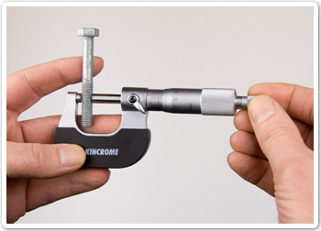
Use the vernier calipers to measure the inside and outside diameter of the conduit.
Place your measured values in the table.
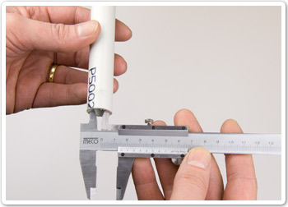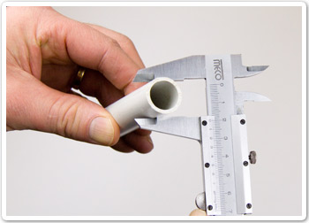

Component | Measurement
Bolt (1)

Bolt (1)

Bolt (1)

Conduit (outside diameter)

Conduit (inside diameter)

Submit the activity
Present your completed task sheet to your trainer for feedback.
Clean up your work area and replace tools and equipment.
Note: This completed task sheet can be saved as evidence of work completed.

