Photos
Photo 1 - Cleared site

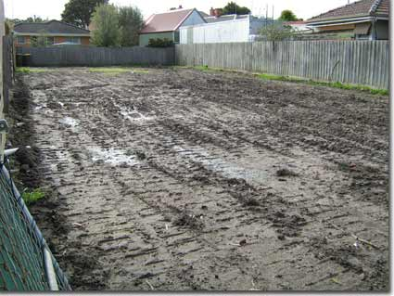
Photo 2 - Existing asbestos house

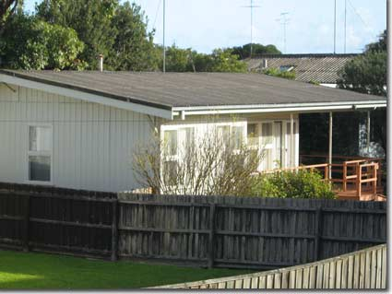

Photo 3 - Finished house

