Design brief for artist's/writer's retreat
You have been commissioned to produce a design concept for a country retreat for a writer and his artist wife.
The clients have requested that the building take advantage of the spectacular views available from the site.
The clients wish the building to be open plan in nature, where practical, to also take advantage of the prevailing winds coming up from the sea in summer. Where practical the building should have large expanses of operable walls/windows.
The clients have also expressed the desire that the form of the building be 'organic' in nature. They also wish the building to intrude as little upon the site's ecology as possible.
The site
The site is accessible from an unmade road at the top of the site and slopes away from the road with an 8° gradient. The site looks down to a small creek that runs across the rear of the property and then down a valley to a stream that runs into the sea. The view of the sea faces south.
Particular attention should be given to the climatic conditions prevailing in the area as this will have an effect on the choice of materials, the siting, and the overall form of the building.
Schedule of accommodation
1. A living space comprising a lounge area, a dining space and a kitchen and include some form of open fireplace in the living space
2. A double bedroom
3. A bathroom connected to:
• bedroom
• living area via separate entry (preferably off service area)
Bathroom facilities:
• spa bath with access to views
• vanity type basin
• toilet
• bidet
• shower
4. A writer's retreat – at upper level – with external space (partly covered, partly open). The retreat should be mezzanine-like in nature above the living space, but with the ability to be able to be closed off, when required
5. An artist's studio in a separate interconnected 'building' linked to the main building
6. A guest area with:
• a bed-sitting room space incorporating a small sink and bench
• a bathroom with shower, toilet and vanity basin.
Guest 'room' to be a separate but interlinked 'building'

Concept sketch

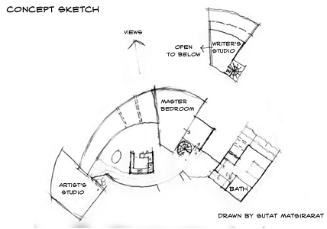

Detailed plan

