Subdivision plan

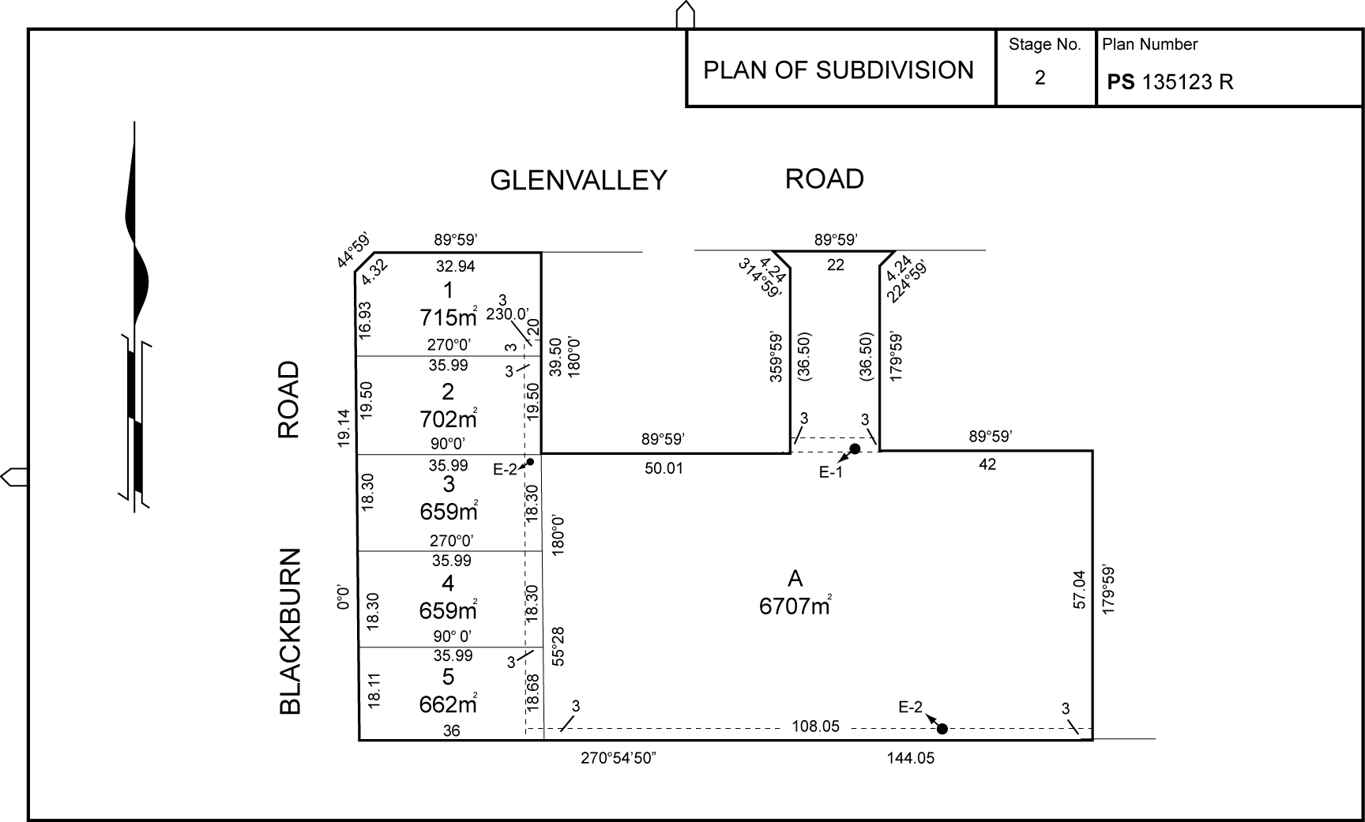

Note that E-1 and E-2 on the subdivision plan are sewer easements.

