Estimating and measuring

This activity will help you develop your skills in estimating and measuring objects.
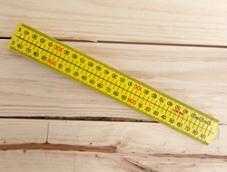
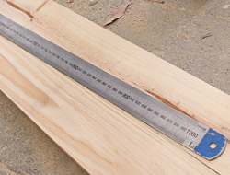

Preparation
You will need the following:
- four fold or metal ruler
- computer
- mobile phone
- desk
- your hand.

Note: If these objects are not available other objects can be substituted, see your trainer for advice.

Step 1
Estimate the dimension of the following objects and write down your judgment.

Step 2
Measure each object and write down their actual dimension.

- The width of your computer screen.

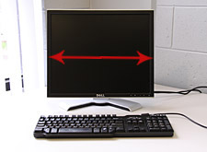 | Estimated width =  Measured width =

- The length of a mobile phone.

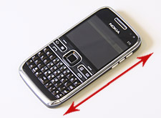 | Estimated length =  Measured length =

- The height of a desk.

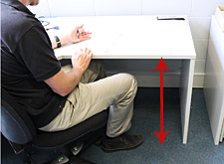 | Estimated height =  Measured height =

- The span of your hand.

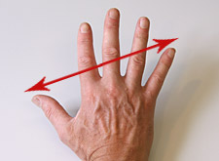 | Estimated span =  Measured span =

Step 3
Compare the two figures, how did you go?

If you think you could improve, try by practicing on different objects.

The more practice you have at estimating and measuring the better you will get.

Step 4
Show your results to your trainer.

