


Trainer guide

Electrotechnology Training Package UEE07

Series 12 Flexible Learning Toolbox

Supporting resources for
UEE30807 Certificate III in Electrotechnology (Electrician)


flexiblelearning.net.au/Toolbox

Table of Contents

Section 1: Overview of the Electrotech Toolbox 4
1.1 Introduction 4
1.2 Qualifications supported 4
1.3 Units of competency 4
1.4 Employability Skills 4
1.5 Target audience 5
1.6 Recognition of prior learning 6
1.7 Toolbox Implementation Guide 7
Section 2 – Organising structure, context and key features 8
2.1 The Toolbox structure 8
2.2 Key features 9
2.2.1 Units 10
2.2.2 Resources 11
2.2.3 Skill recognition 13
2.2.4 Glossary 13
2.3 Aspects learners may find difficult 14
2.4 Customisation 15
2.4.1 Customising a Toolbox for single unit delivery 15
2.5 Hardware and software requirements 16
2.5.1 Hardware 16
2.5.2 Software 16
Section 3: Getting started 17
3.1 Getting the teacher started 17
3.2 Advice on use of materials 17
3.3 Explaining assessment 18
3.3.1 Assessment suggestions 18
Section 4: Tasks and activities 19
4.1 Unit: UEENEEE001B Apply OHS practices in the workplace 19
4.1.1 Unit topics 19
4.1.2 Unit activities 19
4.1.3 Assessment suggestions 21
4.1.4 Related resources 21
4.2 Unit: UEENEEE002B Dismantle, assemble and fabricate electrotechnology components 22
4.2.1 Unit topics 22
4.2.2 Unit activities 22
4.2.3 Assessment suggestions 23
4.2.4 Related resources 23
4.3 Unit: UEENEEE003B Solve problems in extra-low voltage single path circuits 24
4.3.1 Unit topics 24
4.3.2 Unit activities 24
4.3.3 Assessment suggestions 27
4.3.4 Related resources 27
4.4 Unit: UEENEEE004B Solve problems in multiple path DC circuits 28
4.4.1 Unit topics 28
4.4.2 Unit activities 28
4.4.3 Assessment suggestions 30
4.4.4 Related resources 30
4.5 Unit: UEENEEE007B Use drawings, diagrams, schedules and manuals 31
4.5.1 Unit topics 31
4.5.2 Unit activities 31
4.5.3 Assessment suggestions 32
4.5.4 Related resources 32
Section 5: Online delivery 33
5.1 Online teaching strategies 33
5.1.1 Hints for online activities 33
5.1.2 Collaboration and interaction using Toolboxes 33
5.1.3 Starting together as a group – online icebreakers 33
5.1.4 Tips for implementation 34
5.1.5 Social networking for collaboration and interaction 35
5.2 Preparing the learners 35
Section 6: Access and equity issues 36

Section 1: Overview of the Electrotech Toolbox
1.1 Introduction

This Trainer guide has been developed to support you in using the Toolbox as a resource in the delivery of your teaching program. It offers suggested customisation and delivery strategies to maximise the learning experience for your learners. It highlights the positive benefits that can be achieved by encouraging a collaborative learning environment for online learners.
1.2 Qualifications supported

The Electrotech Toolbox supports the UEE30807 Certificate III in Electrotechnology (Electrician) from the Electrotechnology Training Package UEE07. Five compulsory core units for this qualification are included in the Toolbox.
1.3 Units of competency

The five units of competency included in the Toolbox are:
- UEENEEE001B Apply OHS practices in the workplace
- UEENEEE002B Dismantle, assemble, and fabricate electrotechnology components
- UEENEEE003B Solve problems in extra-low voltage single path circuits
- UEENEEE004B Solve problems in multiple path DC circuits
- UEENEEE007B Use drawings, diagrams, schedules, and manuals.

These units are also compulsory in qualifications for associated industry sectors, including transmission, distribution and rail.
1.4 Employability Skills

Employability Skills are skills that apply across a variety of jobs and life contexts. The Commonwealth of Australia defines them as, "skills required not only to gain employment, but also to progress within an enterprise so as to achieve one's potential and contribute successfully to enterprise strategic directions". (Employability Skills Summary, http://employabilityskills.training.com.au/index.php,accessed 30 September, 2009.)

There are eight Employability Skills:
- Communication.
- Teamwork.
- Problem solving.
- Initiative and enterprise.
- Planning and organizing.
- Self-management.
- Learning.
- Technology.

An Employability Skills Summary lists the elements of each skill that have been identified for a specific qualification. To search for an Employability Skills Summary for the qualification supported by this Toolbox, go to http://employabilityskills.training.com.au

Employability skills are embedded into the activities and supporting resources in this Toolbox. The degree of coverage of a skill will vary depending on:
- the type of activity
- the trainer’s delivery method
- whether the learner is completing the activity individually or in a group
- whether the activity is being completed face-to-face or at a distance.

For example, by utilising a social networking tool to plan and conduct a group discussion about emerging technologies for sustainable energy, learners could demonstrate all eight employability skills.

It should be noted that activities in this Toolbox are not intended to be final assessment items. A trainer should be using a variety of assessment methods and instruments to assess skills, knowledge and employability skills.
1.5 Target audience

Many of the learners who participate in Certificate III in Electrotechnology (Electrician) are young (often under 21) and are undertaking an apprenticeship.

These learners tend to demand the option to undertake parts of their course using interactive, screen-based delivery. Increasingly computer literate, they often choose technology as a means for communication, entertainment and information and expect an element of their learning to also reflect this.

This learner group can be characterised as ‘Generation Y’ learners. They are technologically astute, impatient and street-smart. They are turned off by anything without a technology component. They are stimulated by real life learning situations where they are able to experience the learning rather than it being explained to them.

1.6 Recognition of prior learning

Trainers need to explain what recognition of prior learning (RPL) is to learners, and show learners the skill recognition area of the Toolbox.

Learners should be made aware that if they have existing skills and knowledge relevant to a particular unit of competency, that they can investigate the skill recognition area of the Toolbox to help them judge whether to proceed with an RPL application.

For each unit of competency covered by the Toolbox, the skill recognition area provides:
- a description of the RPL process
- an explanation of the term ‘evidence’
- types of evidence that could be needed to address each unit of competency.

The flowchart in Figure 1 shows the RPL path provided in the Toolbox.

Figure 1: RPL path provided in the Electrotech Toolbox.
1.7 Toolbox Implementation Guide

The Toolbox Implementation Guide has been designed to help you get started with using your Toolbox as a teaching resource, and is based on the experiences of training providers nationally who have been working with Toolbox products over the last few years. The guide focuses mainly on supporting teachers involved in Toolbox product implementation, but will also be a useful reference for technical, support and other staff.

It contains four main sections:
- Finding your way around Toolbox products – things you should know.
- Different ways you can use your Toolbox product for training delivery and support.
- Planning for the implementation of your Toolbox product.
- Further reading and helpful websites.

A copy of the Toolbox Implementation Guide can be found at http://toolboxes.flexiblelearning.net.au/documents/index.htm

Section 2 – Organising structure, context and key features
2.1 The Toolbox structure

The Electrotech Toolbox is organised around the five units of competency. Each unit is broken down into a range of topics. From a topic learners can choose a Challenge or Reinforcement activity.

The activities are designed to verify that users have the underpinning knowledge required or to provide them with opportunities to develop that knowledge.

Challenge activities are designed to allow a learner to ‘check their knowledge’ in order to:
- gauge how much they already know
- determine areas of knowledge they need to study in more detail
- gain practice at answering test style questions.

In most cases a percentage score and summary feedback (based on the score) is provided at the end of the challenge.

Reinforcement activities allow learners to develop knowledge in a variety of ways including:
- opportunity to research topics
- opportunity to communicate and share information with other learners
- practice through additional questions and/or activities
- gaining feedback designed to promote discovery learning
- provision of relevant information in sequence with questions and/or activities.

Learners can access additional information in the Resources section relevant to each unit of study.
Figure 2: Electrotech Toolbox site map
2.2 Key features

When learners open the home page, they are greeted with a welcome message and instructions to begin and select a unit. Learners can access each unit via the five graphics on the left side of the home page or through Units in the top menu. The home page of the Toolbox is shown in Figure 3.

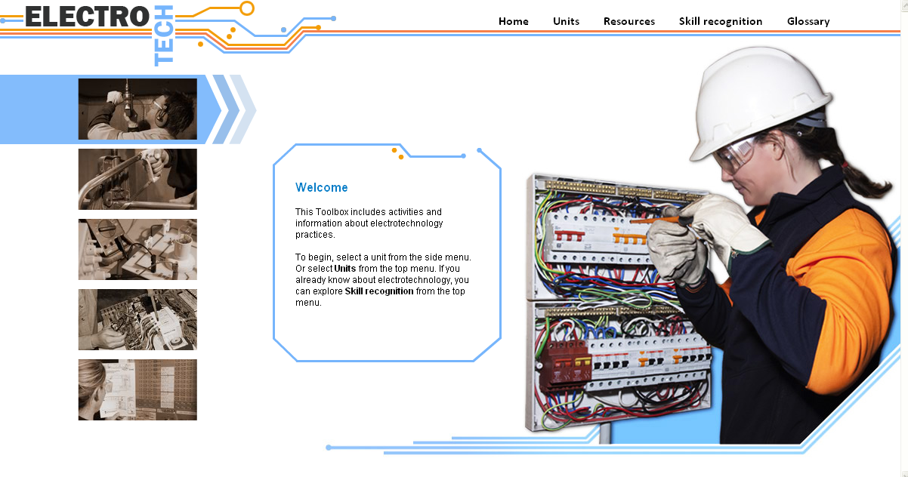
Figure 3: Electrotech Toolbox home page.

The top global menu provides a path to other areas in the Toolbox. Other areas are:
- Units
- Resources
- Skill recognition
- Glossary.
2.2.1 Units

As mentioned, each unit is broken down into a range of topics. From a topic learners can choose Challenge or Reinforcement activities.

For each unit, the associated topics and activities are listed below:

UEENEEE001B Apply OHS practices in the workplace
Topics | Challenges and Reinforcement
Fundamentals | The OHS act
Work environment | Hazards
Manual handling | Manual handling
Hazardous substances | Dangerous goods
Situations | Heights and confined spaces
Hazards | Physical and psychological
First aid | Life support

UEENEEE002B Dismantle, assemble and fabricate electrotechnology components
Topics | Challenges and Reinforcement
Tools | Hand and power tools
Joining techniques | Joining
Measurement | Vernier calliper and micrometer
Drilling and tapping | Drills, taps and dies
Fabrication | Mechanical drawings  Fabrication

UEENEEE003B Solve problems in extra-low voltage single path circuits
Topics | Challenges and Reinforcement
Electrical concepts | Electricity and the industry  Electricity movement
Electrical circuits | Circuit components  Multiples and sub-multiples
Ohm’s law | Using Ohm's law
Power | Power, work and energy
Resistors | Identifying resistors
Current effects | Effects of current
EMF sources | Creating an electromotive force
Series circuits | Solving predictable problems  Connection and measurement

UEENEEE004B Solve problems in multiple path DC circuits
Topics | Challenges and Reinforcement
Parallel circuits | Parallel calculations  Parallel measurement
Series/parallel | Series/parallel calculations  Series/parallel measurement
Resistance | Resistive circuits
Meters | Using meters
Measuring resistance | Insulation testing
Capacitors | The capacitor  Capacitive circuits

UEENEEE007B Use drawings, diagrams, schedules and manuals
Topics | Challenges and Reinforcement
Architectural | Architectural drawings
Electrical | Electrical drawings
Circuits | Lighting circuits

2.2.2 Resources

The Resources section contains resources that are available to the learner at any time. The learner can choose to use some or all of this information when completing Toolbox activities.

Resources may be used independently of the Toolbox and include:
- written information
- examples
- images
- step-by-step procedures
- interactions and animations.

There are also suggestions for other sources of information.

The Resources section opens in a new window so that learners can view information while completing activities.

The Resources home page is shown in Figure 4.

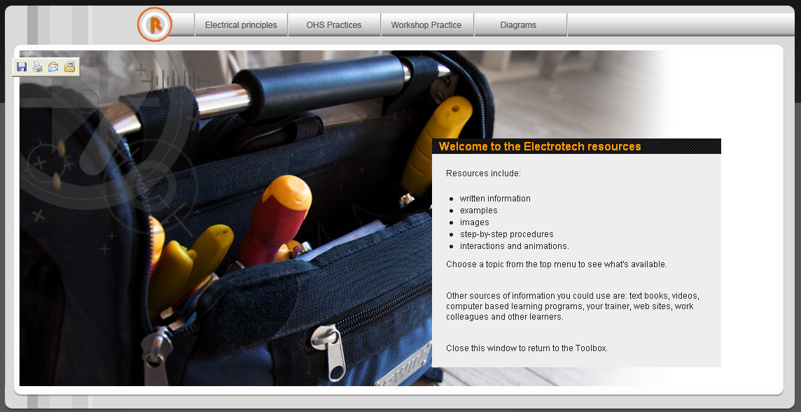
Figure 4: Resources home page.

Resources are accessed using the top global menu. Content is listed below.

Electrical principles | OHS practices | Workshop practices | Diagrams
Introduction | Introduction | Introduction | Introduction
Introduction | Introduction | Introduction | Introduction
Principles | Fundamentals | Mechanical drawings | Architectural drawings
Atomic structure | OHS act | Introduction | Introduction
Electricity | Responsibilities | Drawing sheet | Site plan
Terminology | Workers compensation | Different views | Floor plan
Current | Rehabilitation | Lines | Scales
Voltage | Consultation | Symbols | Symbols
Resistance | Work cover | Freehand drawing | Electrical drawings
Electrical basics | Environment | Workshop practices | Introduction
Units of measure | Hazards | Safety | Block diagrams
Ohm’s Law | Prevention and control | Measurement & marking out | Circuit diagrams
Power | Personal protective equipment | Introduction | Wiring diagrams
Properties | Emergency procedures | Tools | Ladder diagrams
Conductors | Fire | Procedure | Symbols
Insulators | Manual handling | Low tolerance | Cable schedule
Resistance | Definition | Vernier calliper | Lighting circuits
Resistors | Reducing risks | Micrometer | Switches
Capacitance | Hazardous & dangerous | Hand tools | One way
Circuits | Hazardous substances | Introduction | Two way
Series | Dangerous goods | Spanners | Intermediate
Parallel | Hazchem placards | Wrenches | Loop at the light
Series/parallel | Material safety data | Screwdrivers
Conditions | Situations | Pliers
Power | Height | Saws
Relationship | Confined spaces | Chisels
Measurement | Hazards | Files
Meters | Electrical | Hammers
Components | Electrical safety | General measuring
Types | Safety switches | Power tools
Circuit protection | Vibration | Introduction
Creating electricity | Radiation | Portable cordless
Sources | Noise | Portable mains
Current effects | Overuse | Fixed
Physical | Temperature | Safety
Non physical | Stress | Drill bits
Protection | First aid | Types
 | Rescue | Thread cutting
 | First aid kit | Tools
 | COWS | Joining techniques
 | Rescue breathing | Fasteners
 | CPR | Heat joining
 | Duty of care | Sheet metal
 |  | Introduction
 |  | Cutting
 |  | Holes
 |  | Filing
 |  | Folding
 |  | Joining
2.2.3 Skill recognition

Learners with pre-existing skills and knowledge relating to the five units of competency can use the skill recognition section to help them determine whether to pursue a formal application for RPL.

This area can also be used to identify any gaps in skills and knowledge so that learners can work through selected parts of the Toolbox to address these gaps.

The Skill recognition home page is shown in Figure 5.

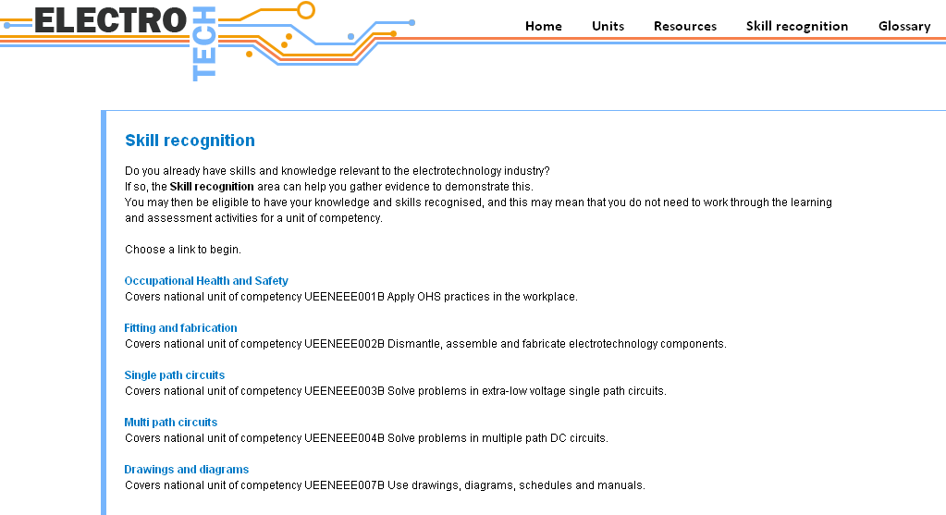
Figure 5: Skill recognition home page.

2.2.4 Glossary

The glossary is an alphabetic listing of words that are used or associated with the content in this Toolbox. It consists of a single html page with alphabetic navigation and links back to the top of the page.

You can customise this page to add further references.
2.3 Aspects learners may find difficult

Learners should not have problems navigating through this Toolbox, and will quickly get used to using the provided tools.

Areas that they may need initial help with are:
- When using Challenges or Reinforcement learners can navigate back to the topics page using the provided menu on the page. An example is highlighted in Figure 6.

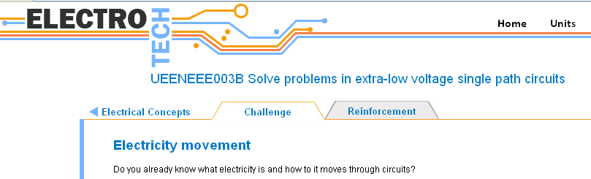
Figure 6: Navigation back to the topics page from a challenge.
- Interactive actives are provided for a number of the Challenges and Reinforcements. Data is presented in this type of application via panels that slide into view. These are navigated using next and back buttons.

As a learner progresses through an application, a progress bar indicates which panel they are currently using via an orange circle. The progress bar provides an alternate method of navigating, by selecting any of the numbered circles. An example is shown in Figure 7.

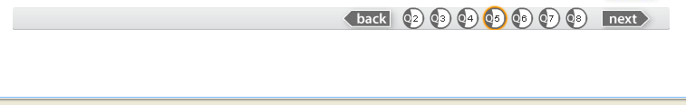
Current panel
Alternative navigation
Figure 7: Interactive application navigation bar.
- When answering questions within activities the user must select the submit button, to get:
- feedback
- a final score at the end of the activity (challenges only).

See Figure 8 for the location of the submit button.

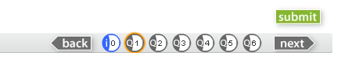
Select submit after answering any question.
Figure 8: Submit button.
- In most Challenges, the learner cannot change the answer after submit has been selected.
- Answers for questions in Reinforcement activities can be changed.
- Images inside the application can be enlarged by selecting the thumbnail provided. The enlarged image can then be closed using the X (close button) provided at the top right of the image.
2.4 Customisation

To customise resources in this Toolbox you will need software such as:
- an HTML text editor such as Homesite®, BBEdit® or Adobe® Dreamweaver to edit web pages.
- a word processor such as Microsoft® Word to edit documents.
- If customisation of multimedia interactions is required, then the following applications may be necessary:
- Flash CS3
- XML SPY or equivalent XML editing tool
- Photoshop/Fireworks (or equivalent) for editing still images
- SoundEdit16 (or equivalent) for editing sound content
- Premiere (or equivalent) for editing video content.

Refer to the Technical guide for further information.
2.4.1 Customising a Toolbox for single unit delivery

If you want to offer one or some of the five units from the Toolbox, you can access the relevant learning objects from the Toolbox repository, or using the Toolbox itself you can disable the links to the unit/s that you do not wish learners to access. This needs to be done in two locations as follows:
- Using Flash open the homemenu.fla file in the folder source\shared\media\flash\homemenu (from the root folder of the Toolbox). Edit lines 37 to 41 of the Action script. The link target for the unit/s you wish to disable should point to shared/disabled.htm. Publish a new shockwave version of the home page and then copy the new homemenu.swf file to the folder toolbox1204\shared\media\flash (overwrite the existing file).
- Using Dreamweaver open and edit the units_home.htm file located in folder toolbox1204\units\. Change the link target for the unit/s you wish to disable to point to shared/disabled.htm.

Now when users click these links they will receive a message saying that content is not available at this time. You can modify the message by changing the content of disabled.htm using Dreamweaver.
To distribute a smaller version by pruning unnecessary content, you will need to follow the above process, and in addition delete appropriate folders in the toolbox1204 folder.

Refer to the Technical guide for further information.
2.5 Hardware and software requirements

Following are some hardware and software requirements. Please refer to the Technical guide for detailed information.
2.5.1 Hardware

To use the learning material in this unit, learners will need a computer with the following features:
- IBM® compatible with a 1000 MHz processor running Windows 2000, XP, Vista, or
- Apple Macintosh® with a 500 MHz processor running OSX v10.3.0 with:
- 256 Mb of RAM
- 1024 x 768 pixel display
- CD-ROM drive
- internet access
- sound card.
2.5.2 Software

Learners will also need the following software/plug-ins installed on their computer:
- Internet Explorer 6.0 or above (http://www.microsoft.com/ )

OR
- Firefox 2.0 or above (http://www.mozilla.com/ )

OR
- Safari 2.0.4 or above (http://www.apple.com/ )
- Microsoft® Word 97 or a similar word processing program to open and use downloadable forms, checklists and worksheets.
- Adobe® Flash Player 9.0.28. If you haven’t got this plug-in, you can download and install the latest free version from: www.adobe.com
- Adobe® PDF Reader 6.0 or above. If you haven’t got this plug-in, you can download and install the latest free version from: www.adobe.com

Incorrect versions of these applications could result in information being shown in an unreadable form or not shown at all.

Section 3: Getting started
3.1 Getting the teacher started

When using the Toolbox from the CD-ROM the index page should automatically open and allow access to the Toolbox via the ‘Enter Toolbox’ link. The index page also provides links for the ‘Trainer guide’ (this document) and the ‘Technical guide’. Figure 9 shows the Toolbox index page.

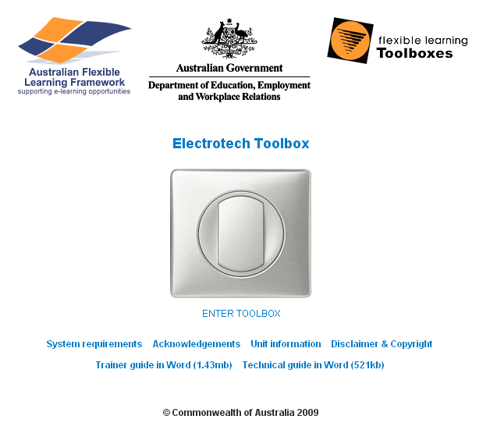
Figure 9: Electrotech Toolbox index page.

After you have entered the Toolbox there is no linkage back to the index page.

If you are delivering the Toolbox content to your learners from a server or Student Management System (SMS), the menu or icon used to start the Toolbox should point to the index.htm file.
3.2 Advice on use of materials

The following tips for trainers highlight important information you should consider when introducing Toolboxes into your training.
- Set aside adequate time to familiarise yourself with the Toolbox so you can properly support your learners.
- Plan ahead and obtain management support.
- Set realistic time frames for implementation.
- Integrate the Toolbox into your teaching delivery, just as you would any new teaching resource.
- Using a Toolbox is not about leaving learners alone to learn for themselves, but about using a new medium as a part of an overall teaching delivery strategy.
- Where possible, provide an orientation to the Toolbox in a practical, face-to-face session with learners actually using the Toolbox. In this session, include clear directions on how you want the learners to work through the Toolbox and define the methods of communication that will be used throughout the course (if applicable).
- If you choose to conduct group activities via discussion boards or wikis, you will need to set up discussion threads/wiki headings prior to commencing the activity.
- You may need to provide instructions to the learners on how to use communication tools such as email, wiki, virtual conferencing or chat.
3.3 Explaining assessment

Assessment of a unit of competency requires the learner to gather sufficient evidence to demonstrate competency for all the required skills and knowledge.

As part of an evidence portfolio, an assessor may choose to use completed worksheets and journals presented by a learner online or face-to-face, as well as meaningful contributions to online discussions.
3.3.1 Assessment suggestions

The Toolbox provides opportunities for learners to gather evidence for assessment. The interactive applications and practical activities available to learners can be completed to contribute to their portfolio of evidence.
Section 4: Tasks and activities

This section provides information about the activities for each of the five units of competency covered in the Toolbox. This includes:
- topics covered
- the purpose of activities
- assessment suggestions
- related resources.
4.1 Unit: UEENEEE001B Apply OHS practices in the workplace
4.1.1 Unit topics

This unit contains seven topics:
- Fundamentals.
- Work environment.
- Manual handling.
- Hazardous substances.
- Situations.
- Hazards.
- First aid.

Learners can progress through the seven topics in any given order.

Each of the seven topics has two associated activities.

Information that will help the learner to complete the activities can be found in the Resources section, under the menu item OHS practices.
4.1.2 Unit activities

This unit contains the following 14 activities.

OHS legislation challenge

The purpose of this activity is to assist learners in determining their level of knowledge of OHS legislation. This will help them to decide on the suitability of RPL, and/or identify areas in which they require further study.

OHS legislation reinforcement

The purpose of this activity is to assist the learner in gaining an understanding of workplace responsibilities as defined by the OHS legislation.

This is achieved by presenting the learner with a range of workplace activities and scenarios involving an employer and employee, then asking them to choose who is responsible. Feedback is provided based on the learner’s choice.

Hazards challenge

The purpose of this activity is to assist learners in determining their level of knowledge of hazard identification and control. This will help them to decide on the suitability of RPL, and/or identify areas in which they require further study.

Hazards reinforcement

The purpose of this activity is to assist the learner in recognising hazards and control methods associated with rotating machinery. The learner is required to view video showing the unsafe operation of a pedestal drill; they are then to note down actions/conditions they believe to be hazardous. Learners are then provided with a list of the hazards and can view a video showing safe operation of the drill.

Manual handling challenge

The purpose of this activity is to assist learners in determining their level of knowledge of manual handling dangers. This will help them to decide on the suitability of RPL, and/or identify areas in which they require further study.

Manual handling reinforcement

The purpose of this activity is to assist the learner in understanding the correct way to lift an object. First the learner is shown a video displaying the incorrect method of lifting, text is provided explaining why the actions are incorrect. The learner is then shown a video and text displaying the correct method of lifting the same object.

Dangerous goods challenge

The purpose of this activity is to assist learners to recognise and safely handle dangerous goods. This will help them to decide on the suitability of RPL, and/or identify areas in which they require further study.

Dangerous goods reinforcement

The purpose of this activity is to assist the learner to identify and classify dangerous goods. The learner is presented with seven different dangerous goods which they must classify. This is achieved by selecting the appropriate class label for each. As they make a selection they are given corresponding feedback.

Heights and confined spaces challenge

The purpose of this activity is to assist learners in determining their level of knowledge of the dangers involved in working at heights or in confined spaces. This will help them to decide on the suitability of RPL, and/or identify areas in which they require further study.

Heights and confined spaces reinforcement

The purpose of this activity is to assist learners in developing an understanding of how to work safely with a ladder. The learner is presented with five steps involved in using a ladder to reach and remove a light fitting. The learner must place the five steps in the correct order. When the order is correct the learner is presented with information on the importance of each step.

Physical and psychological challenge

The purpose of this activity is to assist learners in determining their level of knowledge of physical and psychological hazards. This will help them to decide on the suitability of RPL, and/or identify areas in which they require further study.

Physical and psychological reinforcement

The purpose of this activity is to assist learners with their understanding of the types of physical and psychological hazards. Learners are presented with multiple choice questions. Feedback is given relevant to learner response and is then followed by information relating to the question.

Life support challenge

The purpose of this activity is to assist learners in determining their level of knowledge of life support methods. This will help them to decide on the suitability of RPL, and/or identify areas in which they require further study.

Life support reinforcement

The purpose of this activity is to allow learners in gaining supervised experience in performing CPR techniques on a training dummy. Under the supervision of an appropriate trainer the learner can first observe CPR being performed on a dummy, then practice the skill themselves.
4.1.3 Assessment suggestions

Each of the seven challenge activities are a series of multiple choice questions. The results of these activities can be used as one piece of evidence towards gaining the knowledge component of the unit of competence.

Assessment activities for this unit could include observation of practical tasks, verbal questioning, written tests, research assignments, etc.
4.1.4 Related resources

The following resources may be useful in completing this unit.

Textbook:

Hampson, J 2008, Electrotechnology practice, Pearson Education Australia, Frenchs Forest.

Websites:

St John - http://www.stjohn.org.au

OHS - State and Territories:

Australian Capital Territory - http://www.workcover.act.gov.au

New South Wales - http://www.workcover.nsw.gov.au

Northern Territory - http://www.worksafe.nt.gov.au

South Australia - http://www.workcover.com

Queensland - http://www.workcoverqld.com.au

Tasmania - http://www.workcover.tas.gov.au

Victoria - http://www.workcover.vic.gov.au

Western Australia - http://www.workcover.wa.gov.au
4.2 Unit: UEENEEE002B Dismantle, assemble and fabricate electrotechnology components
4.2.1 Unit topics

This unit contains the following five topics:
- Tools.
- Joining techniques.
- Measurement.
- Drilling and tapping.
- Fabrication.

It is suggested learners complete the fabrication topic last, as it encompasses knowledge and skills gained in the other four topics.

The fabrication topic has four activities, each of the other topics have two activities.

Information that will help the learner to complete the activities can be found in the Resources section, under the menu item Workshop practice.
4.2.2 Unit activities

This unit contains the following 12 activities.

Hand and power tools challenge

The purpose of this activity is to assist learners in determining their level of knowledge of hand and power tools. This will help them to decide on the suitability of RPL, and/or identify areas in which they require further study.

Hand and power tools reinforcement

The purpose of this activity is to assist the learner in gaining an understanding of the operation and use of a pedestal drill. This is achieved by presenting the learner with still images and text describing the features of the drill, then using video to show safe operation.

Joining challenge

The purpose of this activity is to assist learners in determining their level of knowledge of joining techniques. This will help them to decide on the suitability of RPL, and/or identify areas in which they require further study.

Joining reinforcement

The purpose of this activity is to assist the learner in gaining an understanding of the principles of arc welding and brazing. This is achieved by presenting the learner with a range of still images and text describing the welding equipment, safety requirements and welding process. It is suggested that the learner seeks opportunities to practice welding under supervision.

Vernier caliper and micrometer challenge

The purpose of this activity is to assist learners in determining their level of knowledge of using a vernier caliper and micrometer. This will help them to decide on the suitability of RPL, and/or identify areas in which they require further study.

Vernier caliper and micrometer reinforcement

The purpose of this activity is to assist the learner in developing practical skills in using vernier calipers and a micrometer. The learner downloads a Word document describing the practical task to be performed. This task requires them to measure and record the diameter of a range of objects. On completion of the task the learner receives feedback from their trainer.

Drills, taps and dies challenge

The purpose of this activity is to assist learners in determining their level of knowledge of using drills, taps and dies. This will help them to decide on the suitability of RPL, and/or identify areas in which they require further study.

Drills, taps and dies reinforcement

The purpose of this activity is to assist the learner in developing practical skills in drilling and producing threads. The learner downloads a Word document describing the practical task to be performed. The task requires them to mark out and drill a hole in a plastic box. They are then required to use a tap to produce a thread in the hole.

Mechanical drawings challenge

The purpose of this activity is to assist learners in determining their level of knowledge of the conventions, standards and symbols used in mechanical drawings. This will help them to decide on the suitability of RPL, and/or identify areas in which they require further study.

Mechanical drawings reinforcement

The purpose of this activity is to assist the learner in developing practical skills in producing freehand sketches and mechanical drawings. The learner is presented with a three dimensional image of a toolbox. From the image, they are required to produce a freehand and mechanical drawing representation. On completion of the task the learner receives feedback from their trainer.

Fabrication challenge

The purpose of this activity is to assist learners in determining their level of knowledge of performing fabrication techniques. This will help them to decide on the suitability of RPL, and/or identify areas in which they require further study.

Fabrication reinforcement

The purpose of this activity is to assist the learner in developing practical skills in fabricating components. The learner downloads a Word document describing the practical task to be performed. The task requires them to mark out and fabricate a metal box to house a battery charger. On completion of the task the learner receives feedback from their trainer.
4.2.3 Assessment suggestions

Each of the six challenge activities are a series of multiple choice questions. The results of these activities can be used as one piece of evidence towards gaining the knowledge component of the unit of competence.

Assessment activities for this unit could include observation of practical tasks, verbal questioning, written tests, research assignments, etc.
4.2.4 Related resources

The following resources may be useful in completing this unit.

Textbooks:

Culley, R (ed) 1988, Fitting and machining, TAFE Publications Unit, Collingwood.

Hampson, J 2008, Electrotechnology practice, Pearson Education Australia, Frenchs Forest.
4.3 Unit: UEENEEE003B Solve problems in extra-low voltage single path circuits
4.3.1 Unit topics

This unit contains the following eight topics:
- Electrical concepts.
- Electrical circuits.
- Ohm’s law.
- Power.
- Resistors.
- Current effects.
- EMF sources.
- Series circuits.

It is highly recommended learners complete the eight topics in their listed order.

Three of the topics (electrical concepts, electrical circuits and series circuits) have four activities, the remaining have two activities each.

Information that will help the learner to complete the activities can be found in the Resources section, under the menu item Electrical principles.
4.3.2 Unit activities

This unit contains the following 22 activities.

Electricity and the industry challenge

The purpose of this activity is to assist learners in determining their level of knowledge of electricity types/ transmission and the electrical industry. This will help them to decide on the suitability of RPL, and/or identify areas in which they require further study.

Electricity and the industry reinforcement

The purpose of this activity is to assist the learner in gaining an understanding of electricity types/ transmission and the electrical industry. This is achieved by learners working in groups to research information on given topics, then sharing this information with other groups through a choice of presentation methods.

Electricity movement challenge

The purpose of this activity is to assist learners in determining their level of knowledge related to the movement of electricity. This will help them to decide on the suitability of RPL, and/or identify areas in which they require further study.

Electricity movement reinforcement

The purpose of this activity is to assist the learner in gaining an understanding of current, voltage and resistance. This is achieved by learners working on their own or in small groups to research information, then share this information with others through a choice of presentation methods.

Circuit components challenge

The purpose of this activity is to assist learners in determining their level of knowledge of electrical components and their associated symbols. This will help them to decide on the suitability of RPL, and/or identify areas in which they require further study.

Circuit components reinforcement

The purpose of this activity is to assist the learner in developing knowledge of electrical components and their associated symbols. This is achieved by asking learners to move images of components onto the associated symbol on a circuit diagram. Learners receive feedback on their performance.

Multiples and submultiples challenge

The purpose of this activity is to assist learners in determining their level of knowledge of the use of multiples and sub-multiples to express unit values. This will help them to decide on the suitability of RPL, and/or identify areas in which they require further study.

Multiples and submultiples reinforcement

The purpose of this activity is to assist the learner in developing knowledge of the use of multiples and sub-multiples to express unit values. The learner is provided with an interactive ‘multiplier’ to assist them with answering a series of multiple choice questions. Learners receive feedback on their performance.

Using Ohm's law challenge

The purpose of this activity is to assist learners in determining their level of knowledge of Ohm’s law. This will help them to decide on the suitability of RPL, and/or identify areas in which they require further study.

Using Ohm's law reinforcement

The purpose of this activity is to assist the learner in developing skills in using Ohm’s law formula to calculate values. The learner is provided with an interactive Ohm’s law triangle and series circuit to assist them with answering a series of multiple choice questions. Learners receive feedback on their performance.

Power, work and energy challenge

The purpose of this activity is to assist learners in determining their level of knowledge of power, work and energy. This will help them to decide on the suitability of RPL, and/or identify areas in which they require further study.

Power, work and energy reinforcement

The purpose of this activity is to assist the learner in developing skills in calculating power values in given circuits. The learner is provided with an interactive Ohm’s law triangle for power and series circuit to assist them with answering a series of multiple choice questions. Learners receive feedback on their performance.

Identifying resistors challenge

The purpose of this activity is to assist learners in determining their level of knowledge of resistor types and colour codes. This will help them to decide on the suitability of RPL, and/or identify areas in which they require further study.

Identifying resistors reinforcement

The purpose of this activity is to assist the learner in developing knowledge of resistor types and colour codes. The learner is presented with a number of multiple choice questions and receive feedback relevant to their answers. Learners are also directed to complete the practical task of identifying the resistive value of a range of resistors using their colour code, then confirming this value by measuring the resistance with an ohmmeter.

Effects of current challenge

The purpose of this activity is to assist learners in determining their level of knowledge of the effects of current. This will help them to decide on the suitability of RPL, and/or identify areas in which they require further study.

Effects of current reinforcement

The purpose of this activity is to assist the learner in gaining knowledge of the effects of current. This is achieved by learners working in groups to research information on given topics, then sharing this information with other groups through a choice of presentation methods.

Creating an electromotive force challenge

The purpose of this activity is to assist learners in determining their level of knowledge of electromotive force sources and generation. This will help them to decide on the suitability of RPL, and/or identify areas in which they require further study.

Creating an electromotive force reinforcement

The purpose of this activity is to assist the learner in gaining knowledge of electromotive force sources and generation. This is achieved by learners working in groups to research information on given topics, then sharing this information with other groups through a choice of presentation methods.

Solving predictable problems challenge

The purpose of this activity is to assist learners in determining their level of knowledge of using Ohm’s and Kirchoff’s laws to solve problems in series circuits. This will help them to decide on the suitability of RPL, and/or identify areas in which they require further study.

Solving predictable problems reinforcement

The purpose of this activity is to assist the learner in developing knowledge of Ohm’s and Kirchoff’s laws to solve problems in series circuits.The learner is presented with a number of multiple choice and calculation type questions. Learners attempt the questions and are provided with feedback relevant to their answers.

Connection and measurement challenge

The purpose of this activity is to assist learners in determining their level of knowledge of connecting and measuring values in a series circuit. This will help them to decide on the suitability of RPL, and/or identify areas in which they require further study.

Connection and measurement reinforcement

The purpose of this activity is to assist the learner in developing practical skills in connecting and measuring values in a series circuit. The learner downloads a Word document describing the practical task to be performed. This task requires them to connect series circuits and measure voltage and current values. Learners are then required to calculate expected values and compare these against their measured values. On completion of the task the learner receives feedback from their trainer.
4.3.3 Assessment suggestions

Each of the eleven challenge activities are a series of multiple choice questions. The results of these activities can be used as one piece of evidence towards gaining the knowledge component of the unit of competence.

Assessment activities for this unit could include observation of practical tasks, verbal questioning, written tests, research assignments, etc.
4.3.4 Related resources

The following resources may be useful in completing this unit.

Textbook:

Hampson, J and Hanssen, S 2009, Electrical trade principles a practical approach, (2nd edition), Pearson Education Australia, Frenchs Forest.

Website:

How stuff works - http://www.howstuffworks.com
4.4 Unit: UEENEEE004B Solve problems in multiple path DC circuits
4.4.1 Unit topics

This unit contains the following six topics:
- Parallel circuits.
- Series/parallel circuits.
- Resistance.
- Meters.
- Measuring resistance.
- Capacitance.

It is highly recommended learners complete the six topics in their listed order.

Three of the topics (parallel circuits, series/parallel and capacitance) have four activities, the remaining have two activities each.

Information that will help the learner to complete the activities can be found in the Resources section, under the menu item Electrical principles.
4.4.2 Unit activities

This unit contains the following 18 activities.

Parallel calculations challenge

The purpose of this activity is to assist learners in determining their ability to perform calculations involving parallel circuits. This will help them to decide on the suitability of RPL, and/or identify areas in which they require further study.

Parallel calculations reinforcement

The purpose of this activity is to assist the learner in gaining knowledge and experience in performing calculations involving parallel circuits. The learner is presented with a number of multiple choice and calculation questions. Learners receive feedback and information relevant to their answers.

Parallel measurement challenge

The purpose of this activity is to assist learners in determining their level of knowledge related to the connection and measurement of parallel circuits. This will help them to decide on the suitability of RPL, and/or identify areas in which they require further study.

Parallel measurement reinforcement

The purpose of this activity is to assist the learner in developing practical skills in connecting and measuring values in a parallel circuit. The learner downloads a Word document describing the practical task to be performed. This task requires them to connect parallel circuits and measure voltage and current values. Learners are then required to calculate expected values and compare these against their measured values. On completion of the task the learner receives feedback from their trainer.

Series/parallel calculations challenge

The purpose of this activity is to assist learners in determining their ability to perform calculations involving series/parallel circuits. This will help them to decide on the suitability of RPL, and/or identify areas in which they require further study.

Series/parallel calculations reinforcement

The purpose of this activity is to assist the learner in gaining knowledge and experience in performing calculations involving series/parallel circuits. The learner is presented with a number of multiple choice and calculation questions. Learners receive feedback and information relevant to their answers.

Series/parallel measurement challenge

The purpose of this activity is to assist learners in determining their level of knowledge related to the connection and measurement of series/parallel circuits. This will help them to decide on the suitability of RPL, and/or identify areas in which they require further study.

Series/parallel measurement reinforcement

The purpose of this activity is to assist the learner in developing practical skills in connecting and measuring values in a series/parallel circuit. The learner downloads a Word document describing the practical task to be performed, this task requires them to connect series/parallel circuits and measure voltage and current values. Learners are then required to calculate expected values and compare these against their measured values. On completion of the task the learner receives feedback from their trainer.

Resistive circuits challenge

The purpose of this activity is to assist learners in determining their level of knowledge of Ohm’s law. This will help them to decide on the suitability of RPL, and/or identify areas in which they require further study.

Resistive circuits reinforcement

The purpose of this activity is to assist the learner in developing practical skills in measuring the resistive value of conductors. The learner downloads a Word document describing the practical task to be performed. This task requires them to measure the resistance values of a range of conductors at different temperatures. On completion of the task the learner receives feedback from their trainer.

Using meters challenge

The purpose of this activity is to assist learners in determining their level of knowledge of using meters to measure voltage, current, and resistance. This will help them to decide on the suitability of RPL, and/or identify areas in which they require further study.

Using meters reinforcement

The purpose of this activity is to assist the learner in developing skills in measuring voltage and current with a range of meter types. The learner downloads a Word document describing the practical task to be performed, this task requires them to measure the current and voltage using a clamp meter and voltage finder. On completion of the task the learner receives feedback from their trainer.

Insulation testing challenge

The purpose of this activity is to assist learners in determining their ability to test insulation condition using an IR meter. This will help them to decide on the suitability of RPL, and/or identify areas in which they require further study.

Insulation testing reinforcement

The purpose of this activity is to assist the learner in developing knowledge of using an IR meter to test insulation. The learner is presented with a number of multiple choice questions. Learners receive feedback and information relevant to their answers.

The capacitor challenge

The purpose of this activity is to assist learners in determining their level of knowledge capacitor operation. This will help them to decide on the suitability of RPL, and/or identify areas in which they require further study.

The capacitor reinforcement

The purpose of this activity is to assist the learner in gaining knowledge of the operation of a capacitor. The learner is presented with a text/images explaining operation as well as an interaction showing capacitor charging/discharging process. Learners complete multiple choice questions related to this information and receive feedback relevant to their answers.

Capacitive circuits challenge

The purpose of this activity is to assist learners in determining their level of knowledge of capacitive circuits. This will help them to decide on the suitability of RPL, and/or identify areas in which they require further study.

Capacitive circuits reinforcement

The purpose of this activity is to assist the learner in gaining knowledge of capacitive circuits. The learner is presented with text and images explaining the operation of capacitive circuits. Learners complete multiple choice questions related to this information and receive feedback relevant to their answers.
4.4.3 Assessment suggestions

Each of the nine challenge activities is a series of multiple choice questions. The results of these activities can be used as one piece of evidence towards gaining the knowledge component of the unit of competence.

Assessment activities for this unit could include observation of practical tasks, verbal questioning, written tests, research assignments, etc.
4.4.4 Related resources

The following resources may be useful in completing this unit.

Textbook:

Hampson, J and Hanssen, S 2009, Electrical trade principles a practical approach, (2nd edition), Pearson Education Australia, Frenchs Forest.

Website:

How stuff works - http://www.howstuffworks.com
4.5 Unit: UEENEEE007B Use drawings, diagrams, schedules and manuals
4.5.1 Unit topics

This unit contains the following three topics:
- Architectural.
- Electrical.
- Circuit.

It is suggested learners complete the electrical topic before accessing the circuit topic.

Each of the three topics have two associated activities.

Information that will help the learner to complete the activities can be found in the Resources section, under the menu item Diagrams.
4.5.2 Unit activities

This unit contains the following six activities.

Architectural drawings challenge

The purpose of this activity is to assist learners in determining their level of knowledge of architectural drawings. This will help them to decide on the suitability of RPL, and/or identify areas in which they require further study.

Architectural drawings reinforcement

The purpose of this activity is to assist the learner in developing skills in producing an architectural drawing. The learner is presented with a freehand sketch of a one bedroom unit and list of dimensions from which they must produce an architectural drawing. On completion of the task the learner receives feedback from their trainer.

Electrical drawings challenge

The purpose of this activity is to assist learners in determining their level of knowledge of electrical drawing types and associated symbols. This will help them to decide on the suitability of RPL, and/or identify areas in which they require further study.

Electrical drawings reinforcement

The purpose of this activity is to assist the learner in developing skills in producing a wiring diagram. The learner is presented with a circuit diagram and must redraw it as a wiring diagram. On completion of the task the learner receives feedback from their trainer.

Lighting circuits challenge

The purpose of this activity is to assist learners in determining their level of knowledge of connecting lighting circuits. This will help them to decide on the suitability of RPL, and/or identify areas in which they require further study.

Lighting circuits reinforcement

The purpose of this activity is to assist the learner in developing practical skills in connecting lighting wiring using the loop at the light method. The learner downloads a Word document describing the practical task to be performed. This task requires them to draw the required lighting circuits then practically connect the circuits. On completion of the task the learner receives feedback from their trainer.
4.5.3 Assessment suggestions

Each of the three challenge activities contains a series of multiple choice questions. The results of these activities can be used as one piece of evidence towards gaining the knowledge component of the unit of competence.

Assessment activities for this unit could include observation of practical tasks, verbal questioning, written tests, research assignments, etc.
4.5.4 Related resources

The following resources may be useful in completing this unit.

Textbooks:
Hampson, J 2008, Electrotechnology practice, Pearson Education Australia, Frenchs Forest.

Lowe, J F 1988, Drawings for electrical trades, (2nd edition), McGraw Hill, Roseville.
Section 5: Online delivery
5.1 Online teaching strategies
5.1.1 Hints for online activities
- If you are delivering the program online, email may be the primary method of communication with your learners, so ensure that you have a clear system of email folders for managing the traffic.
- If you are not meeting learners face-to-face on a regular basis, keep in contact using your agreed communication method.
- Be clear about timeframes by setting targets for learning. These can help you with your online lesson planning. You will need to set frameworks so your learners know what to do and when to do it.
- Be aware that some learners may be uncomfortable about sharing ideas with other learners.
5.1.2 Collaboration and interaction using Toolboxes

Teaching in an online environment focuses on facilitating and guiding the learner’s progress. Learners have significant learning resources available to them in the Toolboxes, in the workplace and on the internet. Helping your learners to navigate this information and pinpoint the relevant materials to meet performance criteria is your central role. It requires a clear statement of learning objectives and regular feedback from you on learner progress. Email and discussion boards and Web 2.0 technologies are powerful communication tools when applied in this context.

Toolboxes are designed to encourage learner collaboration and you should decide how to facilitate this collaboration. The activities are customisable depending on requirements. For example, you might set up a discussion board topic that includes a start and finish date and a proportion of final assessment weighted to participation. You might notify your learners of these requirements by email, as well as through an initial posting on the discussion board. The discussion board (along with other tools) is a useful record of learner contributions for assessment purposes.

Online discussions will only work if there is a sense of team collaboration, so it is important that you consider how to develop this team environment. Here are a few tips.
5.1.3 Starting together as a group – online icebreakers
- You can use an online icebreaker in a computer training room or with learners who are at different locations.
- If you intend your learners to collaborate online (using email, a learning management system or a web discussion board), it is important to give them a chance to become familiar with each other by using the medium before they get down to the serious part.
- Go to http://www.thiagi.com for some ideas. Follow the link from Free Resources to the Freebies page, then choose Training games.
- Set group projects based on the worksheets and journals.

The downloadable worksheets are accessed throughout the Toolbox.

A small group could:
- work together to research information on a given topic.
- work together to complete a practical task.

Some advantages of this approach are:
- it can facilitate social learning, especially useful if learners are geographically dispersed or isolated
- learners practice using online communication tools in a practical, task-focused way
- it can allow learners to practice planning, collaboration, consultation and networking skills
- it can be integrated with assessment of underpinning skills such as communication skills, and also the key competencies.

Here are some practical suggestions for implementing group projects.
- Limit teams to no more than three or four learners.
- Set a date for completion of the group project.
- Consider asking learners to write a self-assessment of their contribution to the group process. This will encourage learners to reflect on their collaborative skills and provide you with more information if you are considering using the group work as an assessment item.
- Provide guidelines on how you expect your learners to collaborate, for example entirely online, or through a mix of face-to-face meetings and online communication.
- Keep track of learners who are not contributing in group or online activities, they may still be absorbing the information that other learners offer into these conversations and need further encouragement to get involved.
5.1.4 Tips for implementation

Here are some other types of group activities that you may like to adapt. They are in a (very) rough order from easiest to hardest for learners to do online.
- Debate – turn the group work topic into a debate. Assign teams to the ‘yes’ and ‘no’ cases, choose an adjudicator, and hold the debate on your discussion board or chat system. An example could be 'Connecting lighting wiring using the ‘loop at the light’ method is hard to do and takes a long time, it's much better to always wire lights using the ‘loop at the switch’ method'.
- At the coalface – focusing on a particular topic, learners tell each other about their own past experiences. It is usually easy for most people to talk about their own experiences. The questions you set for the group should also encourage some critical reflection, for example ‘What type of workplace accidents or injuries have you witnessed and how could they have been avoided?’
- WebQuest – learners find good websites on a particular topic. The chief idea of a web quest is to search for answers to a problem or a ‘quest’ on the net and then feed the information back to the group either informally or in a report. This can be through discussion, contributions to a wiki, or a group report assembled via instant messaging or emailing contributions in a text document. The facilitator can set different groups to research different aspects of a problem or workplace practice. This is a good way to develop web research skills and collaboration skills at the same time. This would be particularly useful in the tasks relating to finding information on methods of generating electricity.
- Peer review – learner’s team up with a study buddy and give structured feedback on each other’s work on a given task. This is useful for encouraging group collaboration and support, and to practise the important skill of giving and receiving feedback. Use the process of Praise – Improvement – Praise to facilitate this.

- Role play – use this where practising a skill is relevant, such as how you would deal with a situation where you’ve found a co-worker unconscious surrounded by electrical wires. Use role plays carefully. They require some skill on the part of the facilitator. Ensure that debriefing occurs to deal with any issues that come up as the group reflects on and evaluates the interactions. Much of the actual learning comes from this post role play session.
- Blogs – A blog (short for weblog) is a person's online diary. It is regularly updated and 'postings' appear in chronological order. Some blogs allow visitors to make comments or ask questions.
- Wiki’s –A Wiki is used as a group online communication tool. Learners can individually contribute in group discussions, recording business ideas and opportunities. Each learner can add to or change what is posted on the Wiki and learners can set up an alert that sends an email telling them someone has made a new contribution.
5.1.5 Social networking for collaboration and interaction

Every day, your learners communicate with each other in new and different ways. Email, mobile phones, text messaging and podcasts are common forms of communication young people use. They are powerful tools and it stands to reason that if they can be used in everyday communication, they can be used in education too.

Social networking tools allow you to assist learners to network with other learners as they complete Toolbox activities.
For example, you can ask learners to create networks by:
- sharing their work in weblogs, for example writing in their own blog or sharing mobile phone photos in moblogs (mobile weblogs)
- collaborating with others to develop documents, for example using wikis to put together a response to a problem
- creating and sharing photos of their work using photo sharing software
- creating and sharing bookmarks of sites they have found useful in research
- creating and sharing media files capturing their work, for example MP3s or video files
- sharing their evidence for assessment in social networking spaces on the internet
- sharing ideas and information via a virtual conference.
5.2 Preparing the learners

It is recommended that you provide an orientation to the Toolbox in a practical, face-to-face session with learners actually using the Toolbox. In this session, include clear directions on how you want the learners to work through the Toolbox and define the methods of communication that will be used throughout the course (if applicable).

Using a Toolbox is not about leaving learners alone to learn for themselves, but about using a new medium as a part of an overall teaching delivery strategy. Once learners are used to using the medium they will require less support.

Beside the resources that are located in the Toolbox it is highly recommended that you refer your learners to a range of other resources including textbooks, websites, video, etc.
Section 6: Access and equity issues

The Electrotech Toolbox is designed to improve access to study and related outcomes for all clients and potential clients who want to study electrotechnology. It caters for a range of learning styles and purposes by providing multiple entry points. The interface allows learners to navigate in a variety of ways, maximising accessibility.

Learners need to be able to interact with materials that:
- include multiple ways of learning and teaching
- promote equity of learning outcomes.

The target audience has a broad range of educational backgrounds and skills. To accommodate these needs, the Toolbox:
- uses clear, plain English in addition to a glossary
- provides still images and videos
- advises on facilitation for learners who may have literacy difficulties and be lacking confidence as learners, particularly in online learning.

Toolbox contact details:
Flexible Learning Toolbox Help Desk
Phone: 1300 736 710
Email: toolboxhelp@flexiblelearning.net.au
Website: flexiblelearning.net.au/toolbox

For more information contact:
Australian Flexible Learning Framework
National Communication
Phone: +61 7 3307 4700
Fax: +61 7 3259 4371
Email: enquiries@flexiblelearning.net.au
Website: flexiblelearning.net.au
GPO Box 1326
Brisbane, Queensland 4001
Australia

